

ProvenDB for trusted supply chains and sustainability

# ProvenDB for Trusted Supply Chains and Sustainability

# Background

Environmental, Social and Governance (ESG) initiatives increasingly rely on Supply Chain monitoring and management to achieve sustainability goals. At the same time, corporations looking to comply with ESG regulations and aspirations are looking to their Supply Chains for help.

Transparency and trust are essential in ESG Supply Chain initiatives, and blockchain technology can be used to enable this trust and transparency. However, Blockchain technology has integrity, economic, environmental, and performance limitations that must be addressed before these ambitions can be realized.

ProvenDB can bridge the gap between ESG requirements and Blockchain capabilities and is an excellent platform for trusted Supply Chain Management.

# Supply Chains and ESG

Supply Chain management provides enormous Environmental, Social, and Governance (ESG) opportunities[1]. In particular:

* Optimization of Supply Chains provides opportunities for improving efficiency and reducing environmental impact.
* Transparency of the Supply Chain is increasingly critical to demonstrating a commitment to and progress towards ESG objectives and regulations.
* A well-implemented Supply Chain provides the ability to determine the provenance of products allowing consumers to make informed production sustainability choices, and providing marketing advantages to the creators of sustainable products.

There are significant challenges involved in implementing a trusted, comprehensive and transparent Supply Chain. These include:

* Ensuring the accuracy of source data entry.
* The implementation of a unified Supply Chain platform spanning multiple organizations and jurisdictions.
* Guaranteeing the integrity and trustworthiness of data as it transitions through the chain, and ensuring that historical records are unimpeachable.

## The role of Blockchain

Blockchain technology cannot provide a complete solution for all Supply Chain challenges. However, Blockchain technology allows Supply Chain records to be provably immutable and impervious to tampering, redaction or concealment.

In a perfect world, a company’s Supply Chain records could be taken at face value. However, consumers are aware that even the largest and most reputable companies may be manipulating data to falsly claim sustainability.

Ensuring that source ingredients or components are accurate is one area of focus. It typically involves corroboration of source data from multiple sensors and the use of "smart" watermarks and tags that cannot be easily falsified. But as data moves through the Supply Chain, the ability to retrospectively alter these records remains a possibility with conventional technologies.

Blockchain technology allows Supply Chain records to be immutable, removing the possibility of post-facto tampering and radically increasing the trustworthiness of the Supply Chain. Blockchains also implement features that can be used to create "digital twins" of products or components through non-fungible tokens (NFTs) and have built-in strong identification mechanisms.

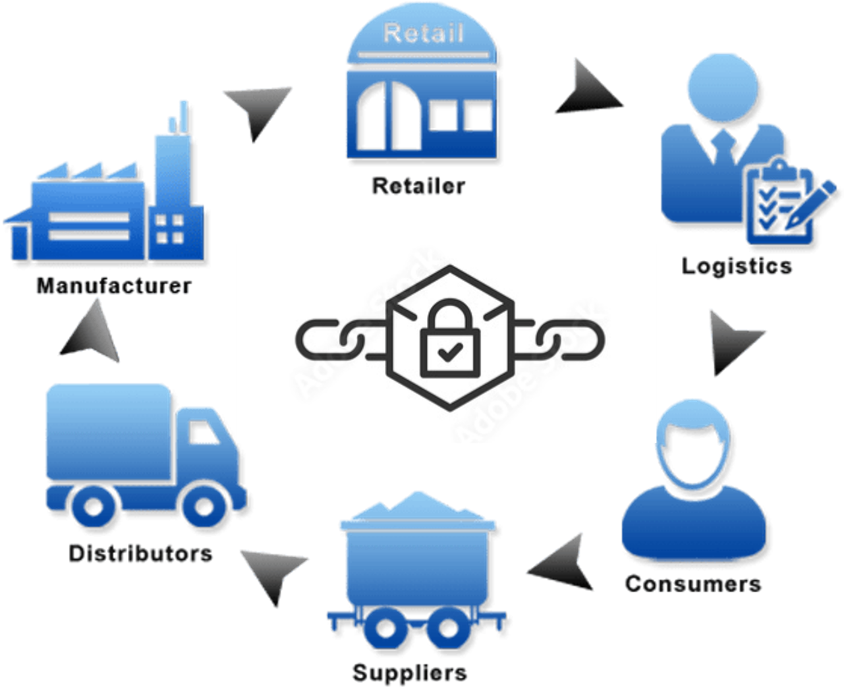

Figure 1 Blockchain can add trust to every step in a Supply Chain

## Blockchain challenges

The use of Blockchain to improve Supply Chain management was the focus of much early excitement during the first blockchain boom as organizations realized the potential for increased trust and integrity outlined above. However, most blockchain-based Supply Chain initiatives stalled because of some fundamental limitations of blockchains:

* **Blockchains were unable to store all the data required**. Blockchain transactions typically have very limited payloads. It is not possible, for instance, to include complex or voluminous data within a blockchain transaction. Data relating to the transaction must therefore be stored 'off-chain'. This off-chain data can be subject to manipulation.
* **Blockchain transactions are often uneconomical**. At the time of writing, the "trusted" public blockchains – Bitcoin and Ethereum – required transaction fees of $5-$50 *per transaction*. At scale, these transaction fees ruin the economics of blockchain-based Supply Chains. There are indeed cheaper blockchains, but they lack the cryptographic strength and trustworthiness of the major chains, and their longevity is not assured.
* **Blockchains cannot support the transaction volumes required**. The major chains' transactional throughputs and transaction latencies are unacceptable for almost any Supply Chain activities. Ethereum, at the time of writing, supports only 30 transactions per second (TPS). Even when Ethereum 2.0 arrives in late 2022 with 100,000 TPS, this may still be inadequate for massive Supply Chains.
* **Some blockchains have an unacceptable carbon footprint**. Bitcoin and Ethereum, in particular, use the computationally expensive "Proof of Work" algorithm to achieve consensus. Proof of Work results in very high carbon footprints for these chains[2].

These restrictions create dilemmas for those seeking to use Blockchain in Supply Chain Management:

* Implementors must choose between the high-trust public blockchains with their high carbon footprint, high costs and low throughput, or choose a lower footprint blockchain that might not stand the tests of time or deliver the desired level of trust.
* There is no good solution for the storage of off-chain data. Some data must be stored off-chain, and this data represents a weak link in the chain of trust.

# How ProvenDB can help

ProvenDB solves many of the problems inherent in Blockchain for Supply Chain management.

ProvenDB combines traditional database services' functionality, performance, and economics with the immutability and proof of public blockchain solutions. Data in a ProvenDB database is validated by on-chain transactions on public or private blockchains. In this way, ProvenDB solves the issue of off-chain data storage.

Furthermore, ProvenDB aggregates large numbers of transactions into a single blockchain transaction. This single transaction can prove the provenance of hundreds of thousands or even millions of database records. Consequently, the environmental, economic and performance penalties involved in Blockchain transactions are radically reduced.

*ProvenDB resolves the issue of off-chain data integrity and radically reduces the environmental, economic and performance costs involved in Blockchain transactions.*

## How it works

When data is added to or modified in a database being monitored by ProvenDB, cryptographic signatures of the data are created. These signatures can be "signed" by your company's cryptographic key (possibly the same key that guarantees the identity of your website).

Cryptographic signatures are aggregated across multiple database records – potentially millions. A single signature can be used to prove the integrity of the entire database state or any individual document within the database.

After aggregation, these signatures are anchored to a public Blockchain such as Bitcoin, Hedera or Ethereum, or a private Blockchain such as HyperLedger. Since each signature attests to the state of a vast number of records, the number of Blockchain transactions required is minimized.

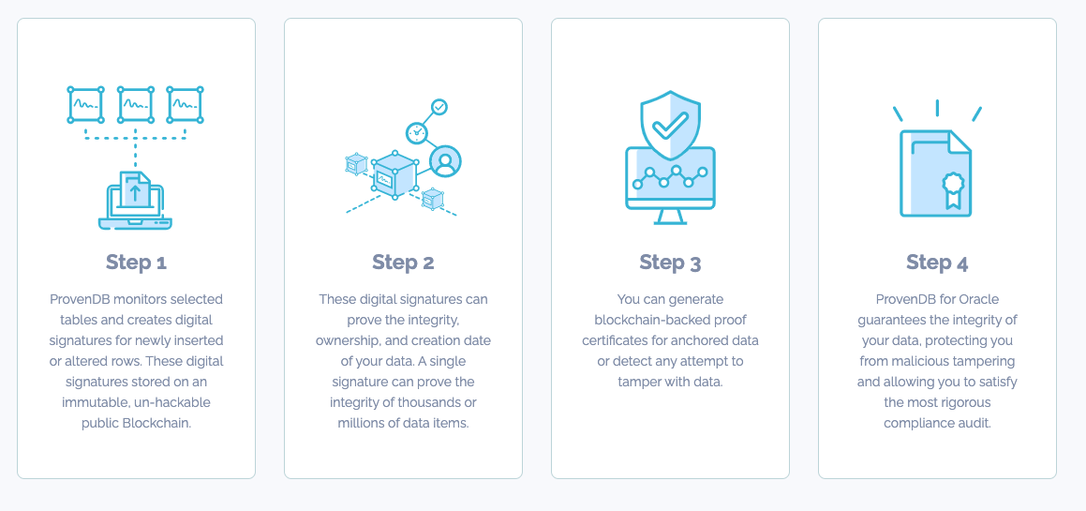

Figure How ProvenDB works

Once anchored to the public Blockchain, the signatures form an impeccable and irrefutable proof of the integrity and origin time of the data concerned. The Blockchain record – which cannot be altered by any known technology – proves the overall integrity and timestamp of items in the database, eliminating any possibility of undetected tampering or backdating.

ProvenDB offers a flexible and broadly applicable solution. Digital signatures can be sent directly from various APIs, through integration with existing database systems, or with the ProvenDB managed database solution, or via an email gateway. A variety of private and public blockchains are supported.

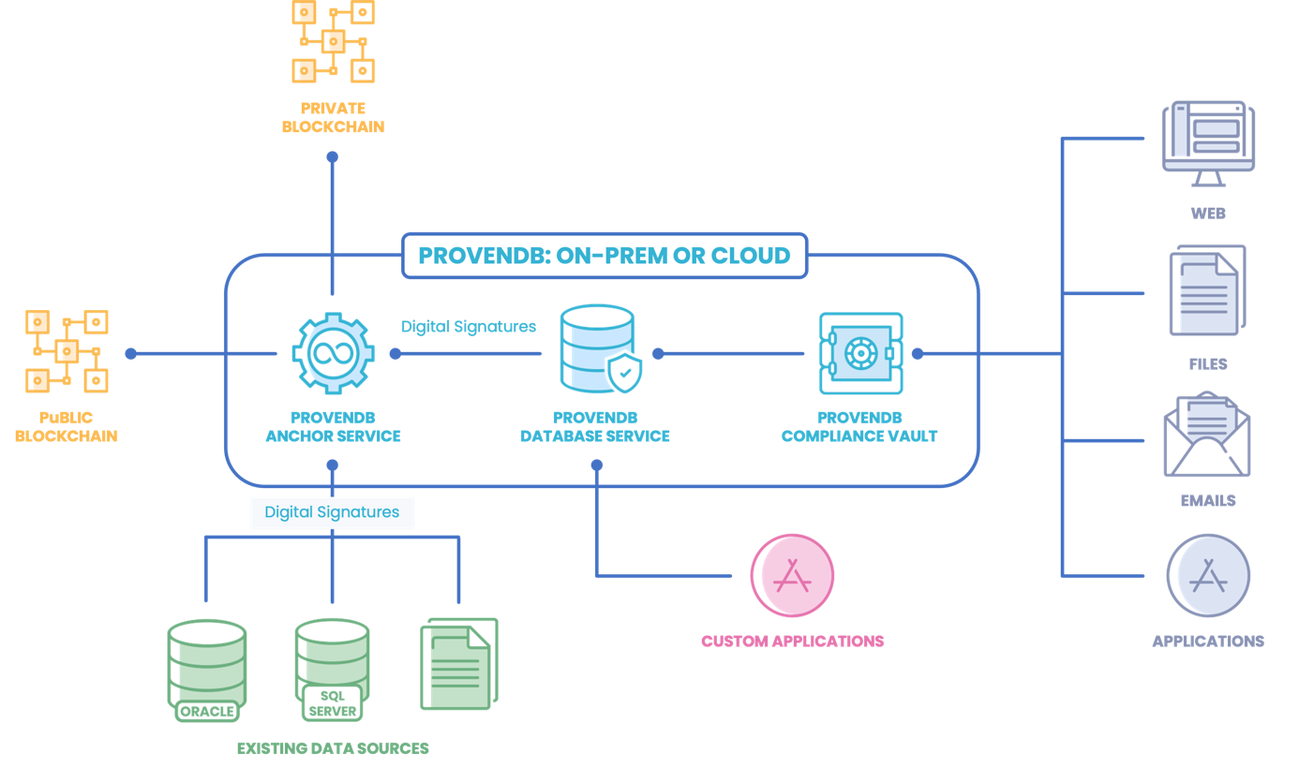

Figure ProvenDB Architecture

Our default and recommended Blockchain is Hedera – which has a particularly low environmental footprint[3].

## ProvenDB and Digimarc

Digimarc are leaders in digital watermarking which contributes to ESG initiatives by improving supply chain visibility, product provenance information and document integrity.

Using Digimarc watermarks and the EVRYTHNG production cloud, supply chain owners can track and verify products and product components as they move through a supply chain. Using Digimarc, companies can authentically make claims about their supply chain, increasing trust between significant stakeholders and consumers.

However, a challenge remains. In the past decade, consumers have become significantly more complex in understanding the supply chain and how some bad actors within industries can fabricate or manipulate data to convince users their products are more ethical or sustainable.

Even with Digimarc's added authenticity, skeptical or sophisticated consumers may ask themselves if they can trust this data. After all, isn't there still a significant incentive for bad actors inside an organization to manipulate, backdate or delete data for financial gain?

As noted earlier, Blockchain technology stands to massively increase the level of trust inherent in any supply chain tracking effort. With the visibility and traceability provide by Digimac is coupled with the trustworthy data storage of ProvenDB, we move towards a far higher level of trust and transparency.

# Conclusion

Effective Supply Chain management is a critical component of effective ESG programs. Blockchain can increase the trust and transparency of Supply Chains. ProvenDB can provide trusted off-chain storage and radically reduce the environmental and economic costs associated with Blockchains. ProvenDB can therefore add value to any trusted Supply Chain implementation.

Digimarc technology provides massive increases in the tracability and transparency of supply chains. We believe that coupling ProvenDB and Digimarc technology could result in huge improvements in supply chain and sustainability efforts

*Eliminate the costs and risks involved in regulatory compliance with ProvenDB.  
Visit* [*www.provendb.com*](http://www.provendb.com) *to sign up for a ProvenDB cloud service, or email us at* [*support@provendb.com*](mailto:support@provendb.com)*..*

1. <https://fardapaper.ir/mohavaha/uploads/2018/09/Fardapaper-Supply-Chain-Integrity-A-Key-to-Sustainable-Supply-Chain-Management.pdf>
2. Ethereum is in the process of transitioning to a more environmentally friendly Proof of Stake algorithm during 2022.
3. <https://hedera.com/ucl-blockchain-energy>